**Newsletter**



**Target Range Sewer & Water District Newsletter**

**Spring 2021**

**\*\* *WELCOME NEW MEMBERS* \*\***

***The Target Range Sewer & Water District Board and Members (District) give a hearty welcome to our new members. The District began with 80 members back in 2000 and has now grown to over 1,400 today. Our new members are all located within the Orchard Homes area and have been neighbors of the District since our inception. We greatly appreciate your willingness to become a part of the District and its mission.***

**A Trip Down Memory Lane**

It has been over twenty years since the Target Range Sewer and Water District was formed (April 5, 2000). The District’s mission is the same as it was in 2000, ***“Preserving our quality of life through planned management of our water resources”***. The District has helped numerous members solve issues involving water and septic problems. We have all seen the increase in cost associated with owning property in the District, but one cost has never increased and that is the District’s charge to our members, from the District’s beginning, $23.90 annually. If only the other taxes and costs of home ownership remained the same, it would be a wonderful world.

**Area TRSWD Trivia Question**

***What place or thing in our area has in its name three (3) sets of double letters?***

***(answer on last page)***

**Newsletter Major Contents**

***\* District Developments***

***\* Proposed District Developments***

***\* Missoula CITY/County Property Density Policies***

***and Missoula CITY Annexation Policies***

***\* Cesspool Replacement Program***

***\* Website and Facebook Services***

***\* District Contact Information***

***\* What do you know about your well***

***\* Flush Carefully***

***\* Message from Board***

***\* Expansion Maps***

**District Developments**

There is an ongoing development in the District at McCauley Meadows II which is located on South Ave., west of the Target Range School in the 4200 block. This development eventually will consist of five homes on 1 acre parcels with their own well and septic systems. There are currently two new homes built with two more to be built and one older home to be remodeled or replaced.

**Proposed District Developments**

There is a new development in the District that was approved back in May 2017 and is located on Spurgin RD in the 4400 block. It is called Spurgin Ranches Subdivision and consists of 20 acres and will have 18 to 19 homes built on one-acre parcels. This development has been very active of late. The District has been in contact with the Missoula County Planning Board in reviewing this development and will be involved in its final approval.

There is an ongoing proposed development of McCauley Meadows east of Humble Rd and south of Sundown. This development has been proposed with numerous revisions that are still under review. We will keep you posted. The Board of County Commissioners once again denied the subdivision at their April 22, 2021, meeting.

If you are aware of any new planned development or have a concern about one, please contact the District through our website: [www.targetrangeswd.org](http://www.targetrangeswd.org)

**Missoula City/County Planning Density & Annexation Policies**

Since the City and County Planning Board announced their new Density Policies, the District has attended meetings concerning these policies. These plans outline how the number of dwellings, either single family homes or apartment complexes will increase the existing land use policies (1 dwelling per acre). These plans include the areas from Reserve to Tower and 3rd to South Avenue. Since the addition of our new members this becomes a much greater issue to the District than before.

As reported in our last newsletter and on the website, the District was not contacted by the City/County Planning Board in regards to their policy changes and encroachment into the District’s authority without notification. We held meetings regarding this issue and were assured it was just an oversight by the County and they would make sure the District will be involved with any new planning made by them. Along with the County and City Density planning, the District is working to protect the rights of our members.

You may view the entire City/County Planning Board policies and also the City Annexation Policy by visiting our website for links to the City and County websites: [www.targetrangeswd.org](http://www.targetrangeswd.org).

The District will attend as many Missoula City and County meetings as possible, keeping you informed of any changes to policies that may affect the District and our way of life.

**Cesspool Replacement Program**

To date the Target Range Sewer & Water District has awarded over 20 grants assisting our members in the replacement of cesspools or upgrades of existing septic systems within the District. If you replace a cesspool, the district may award you a grant up to $3000 towards your costs. Grants start at $500 for the repair or upgrade of septic systems. Grant requests along with a written bid or estimates need to be submitted to the Board. For more details, please visit our website [www.TargetRangeSWD.org](http://www.TargetRangeSWD.org).

## General info for Septic & Well Maintenance

In 2001, an independent market survey sponsored by the National Ground Water Association (NGWA) found 78% of private well owners prefer drinking water from their own well.

Recently one of our members reported to TRSWD that they had their well-water system tested by a commercial water treatment company. The company reported to the owner that the water they tested, without any addition of filtering or added water treatment, was superior to the City of Missoula water, which they also test. These tests dealt with foreign particulates and bio-elements and they recommended no changes to his drinking water system. There was only a recommendation made to maintain his current water softener unit for hot water use.

Refer to our website for information concerning well and septic maintenance: [www.targetrangeswd.org](http://www.targetrangeswd.org)

**What do you know about your well?**

It is important that private well owners take a little time to learn about how to be a good steward of their water-well systems, which includes testing the water and acting to improve water quality if necessary.

Here’s a short quiz to test your knowledge:

1. **It is important to test one’s well water annually for:**
2. Iron
3. Hardness
4. Sulfides
5. Bacteria
6. Nitrates
7. d and e
8. All of the above
9. **A local health or governmental department is a good place to start checking on potential groundwater contamination threats:**

True or False

1. **One’s well maybe dirty if:**
   1. The water is cloudy
   2. The water flow into the well is slow
   3. There are taste and odor problems
   4. All of the above
2. **Nitrates most commonly come from manufactured sites:**

True or False

1. **Total coliforms are tested in water because:**
   1. These bacteria are hazardous to one’s heath
   2. They are easy to grow in lab test
   3. They are an indicator of possible pathogenic bacteria
   4. b and c
   5. All of the above

**Quiz answers:**

1. f (2) True (3) d (4) False (5) d

## Flush Carefully to Help Maintain Your Septic System

A good rule of thumb for septic systems:

Don’t flush anything that you didn’t eat. Homeowners wanting to take good care of their septic systems will note the following items should never be put down the drain or in the toilet. These items can clog pipes or drainfields and damage the biological digestion that takes place within a septic system.

**Take care NOT to flush the following:**

* Hair, coffee grounds, dental floss, diaper wipes. Kitty litter, grease, oil, hygiene products, cigarette butts, paper towels.

**Never flush chemicals or medications that could contaminate groundwater such as:**

* Paints, varnishes, thinners, oils, photographic solutions, pesticides. These are hazardous materials and should be disposed of properly.
* Prescription medicine should never be flushed. They should be replaced in their original container and disposed of properly.

**Grease goes in the garbage, not down the drain**

* Grease, fats, and oils that go down the sink can stick to the pipes inside the septic system. Overtime they build up and can plug pipes. Grease is harmful to the proper operation of a septic system and drainfield.
* Reuse old food containers to store grease. When the container is full, seal it in a plastic bag and place it in the garbage.

**Minimize Heavy Cleaners and Chlorine Blech**

* Overuse of chlorine bleach and industrial cleaners will kill the beneficial bacteria that live in a septic system.
* A better solution is to use oxygenated bleach for laundry, and baking soda or vinegar solutions to clean sinks, showers, toilets, and coffee pots. These items are beneficial to a septic system.

**Protect the Drainfield from Damage**

* Do not drive over the drainfield
* Do not plant a garden over a drainfield
* Do not plant trees within 30’ of a drainfield
* Do not build any structure over it, or cover it with concrete or asphalt

***Trivia Answer: BITTERROOT – The Bitterroot River flows through the District prior to joining the Clark Fork River and is also our State Flower.***

**TRSWD Contact Information**

Board Members : Fred Jones – Chairman – 239-4300

Mitch Ferm - 529-3476

Norm Smyers – 543-9775

George Hart – 396-8245

Scott David - 381-6229

Business Manager : Larry Nagy – 218-8627

District Mailing : PO Box 5484

Address : Missoula, MT 59806

Office Location : 1705 South Reserve

Missoula, MT 59801

Email Address can be obtained at District Website.

[www.targetrangeswd.org](http://www.targetrangeswd.org).

## Message from Board

*In closing, it is the time to begin summer projects. We, the Target Range Sewer and Water District Board, wish you the best in your endeavors, whatever they may be. We look forward to working with you in the year to come.*

**EXPANSION MAPS:**

**NEW MEMBERS AREA (blue) NEW TRSWD DISTRICT AREA (green & blue)**

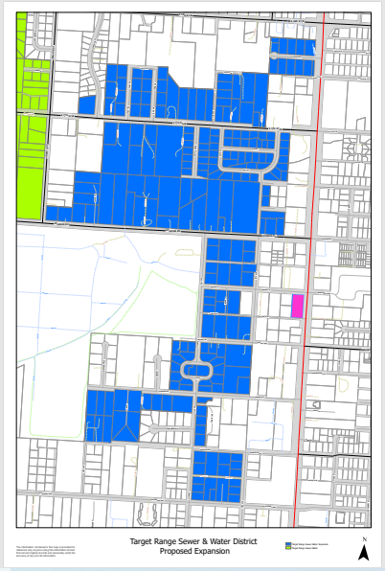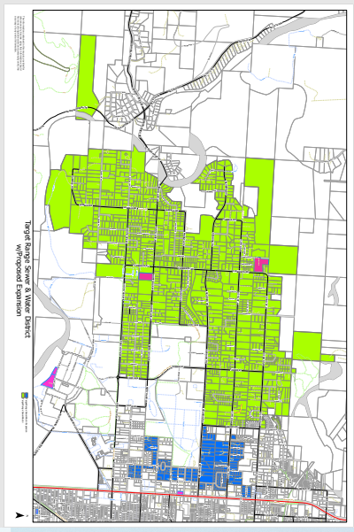

***Preserving our quality of life through planned management of our water resources***

Target Range Sewer and Water District

P.O. Box 5484

Missoula, MT 59806